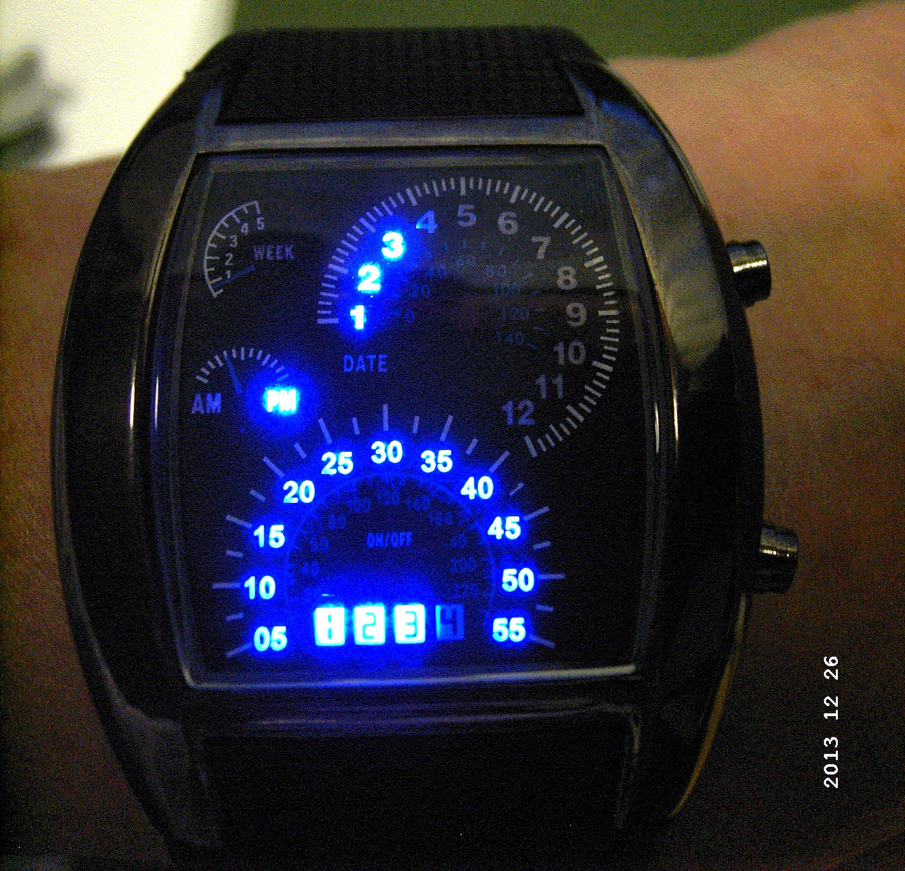
at top key A and down key B

The LED-watch of the year 2017 - all digital - 259,50 US$ from USA

individual designed military sports-wristwatch

if you like very very special at your own

at any demand only 19,95 € limited at 1 piece / Person

( free for VIP costumers and turnover above 300 € within a half year)

U S E R S M A N U A L

Time display
The time will be displayed after the light turns on by pressing button A one times.

Hours displayed at the upper face and minutes displayed at the lower face. Minutes displayed in steps of 5 minutes, additionally the supplementary minutes (1 – 4) come up down in the digital display.

PM lights for the afternoon, if PM does not shine so it's morning. In the figure: its 3:58 in the afternoon.

Date display
Press button A until the date-LED is on (2 xs), which means the current date is displayed. Month displayed in the upper face and days displayed in the lower face.

Display the day of the week
Press button A until the week-LED "week" is on (3 xs), which means the day of the week will be displayed. In the upper left face the number 1 for monday, 2 for thuesday, 3 for wednesday, 4 for thursday, 5 for friday, 6 for saturday and 7 for sunday will be digital displayed.

Time setting
Press button B (2 xs) to enter into the hour setting mode, where hour icon twinkles and press button A to set the hour needed. Then press the button B again to enter in the minute setting mode, where the minute icon twinkles and press the button A to set the minutes needed.
Date setting
Press Button B until the LED "date" turns on (4 xs), you enter in the month setting mode and the month in the upper face twinkles. Press the Button A to set the needed month.

You press the button B again to enter into the day setting mode. The day twinkles in the lower face, then press the button A to set the needed day.

Setting the day of the week
Press the button B until the "week" icon light (6 xs) to enter into the day of week mode in the upper left face when the week icon twinkles.

Now you press the button A to set the day of the week from 1 to 7.

LED light brightness grade setting
Press the button B until 4 different numbers in the upper face appear (7 xs) to enter into the brightness setting mode and the 1 to 4 numbers in the grade indication twinkles.

Now you may set the brightness within 4 different brightness grades from "low like 1" to "high like 4".

Time interval setting for automatic time display ( that may be a really eye-catcher )
Press the button B until the icon ON/OFF light (8 xs) to enter into the setting mode for time interval setting the automatic time display. If the icon twinkles this function will be disabled all the time, if this icon light this function will be enabled.

With button A you are able to set the time interval in the lower face to 5 – 10 – 15 – 20 – 25 or 30 minutes, with an additional pressing the Button A you switch the automatic on or off, indicated with twinkle or continuously lighting of the icon ON/OFF.

The time display will be light up automatically depends on the saved number of minutes.
The duration of the display will be generally about 5 seconds.

Spezification:

100% brand new super modern designer-outline in super quality
Warranty: 4 years at all factory faults depending to ISO 9000
Case and Case/rack: stainless steel
Extremely exact japanese quartz movement chronometer computer
Brightness settable in 4 different steps 1 to 4
LED digital lighting displays: hours, minutes, AM/PM, date and day of the week
Item type: military LED wristwatch for men
Sports type: running watch
Display window - type of material: Hardlex
Material of case: stainless steel
Band material : skin friendly synthetic / rubber
Display type: digital at different tachometer faces
Case shape: rectangle
Dial size: approx. 5 x 4,2 x 1,1 cm (L x W x T)
Band length: app. 24 cm (include buckle)
Band width: app. 2,2 cm
Color: black

